Document 2

**User Manual**

**Open the website**

<https://mahmoud-samaha1.github.io/Market-Project/products>

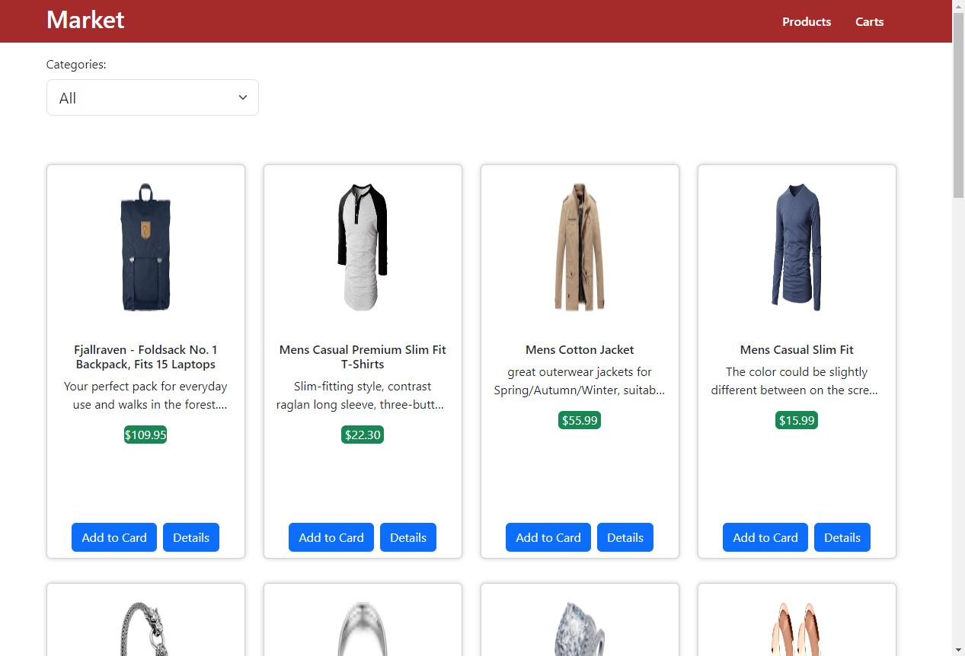

**User** can filter products from Categories Label

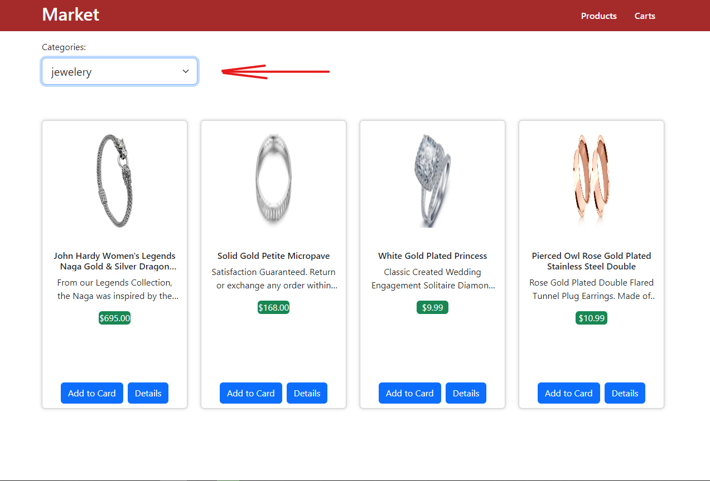

**User** can show details of the product by clicking on ths card or details button: 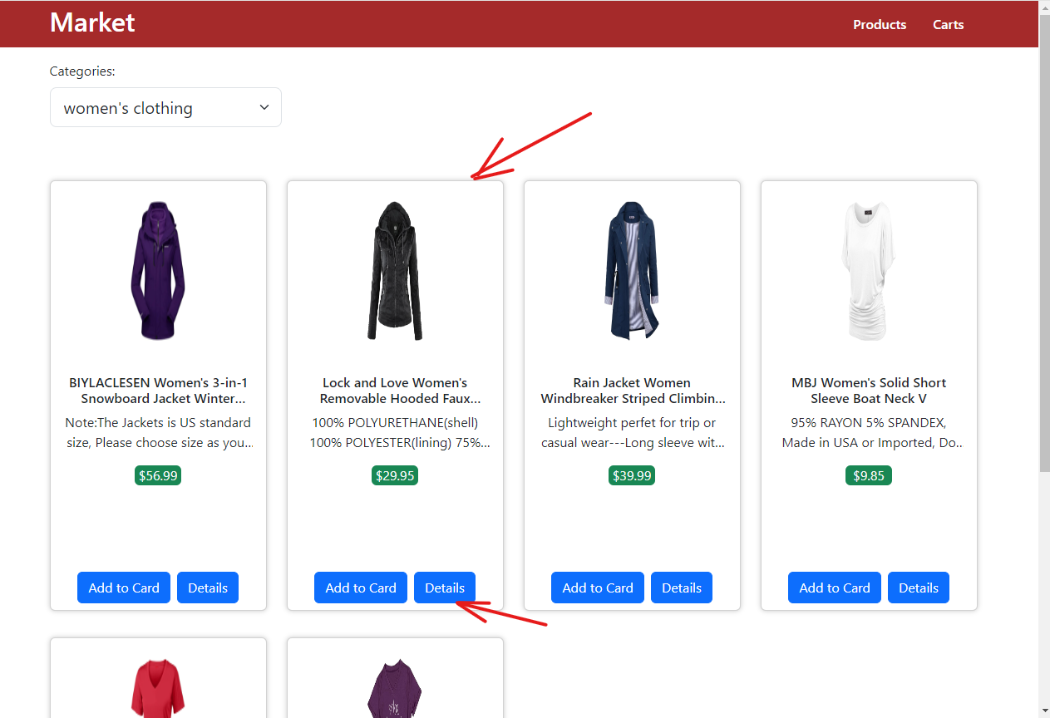

**User** can go back to products page by clicking products in navbat or back button: 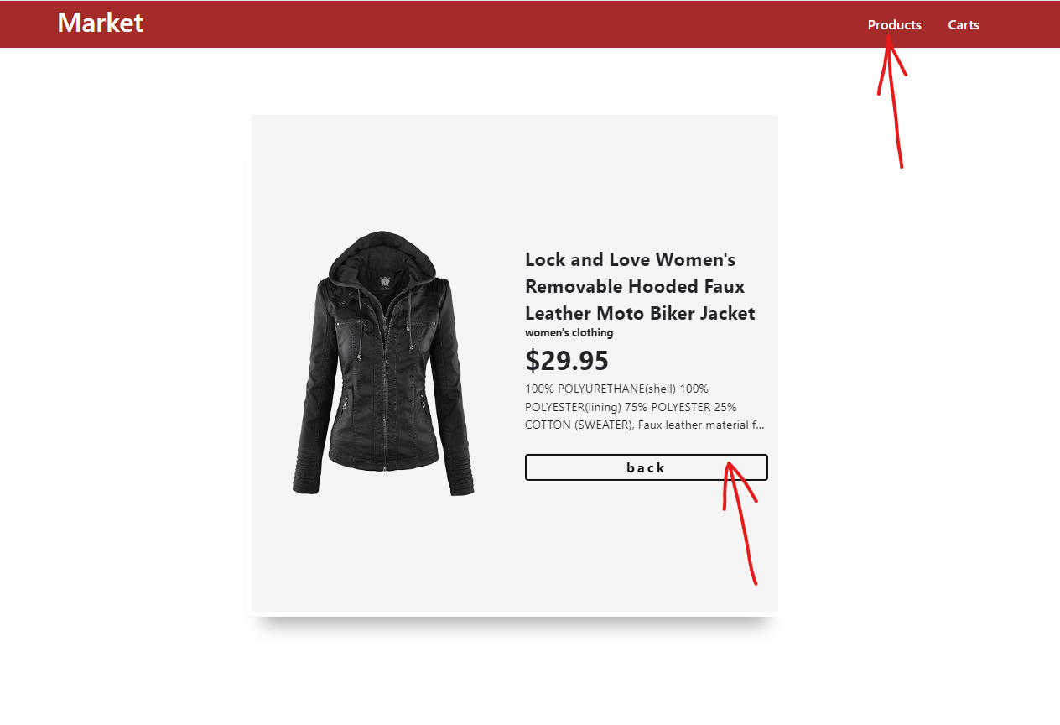

**User** can add products to cart :

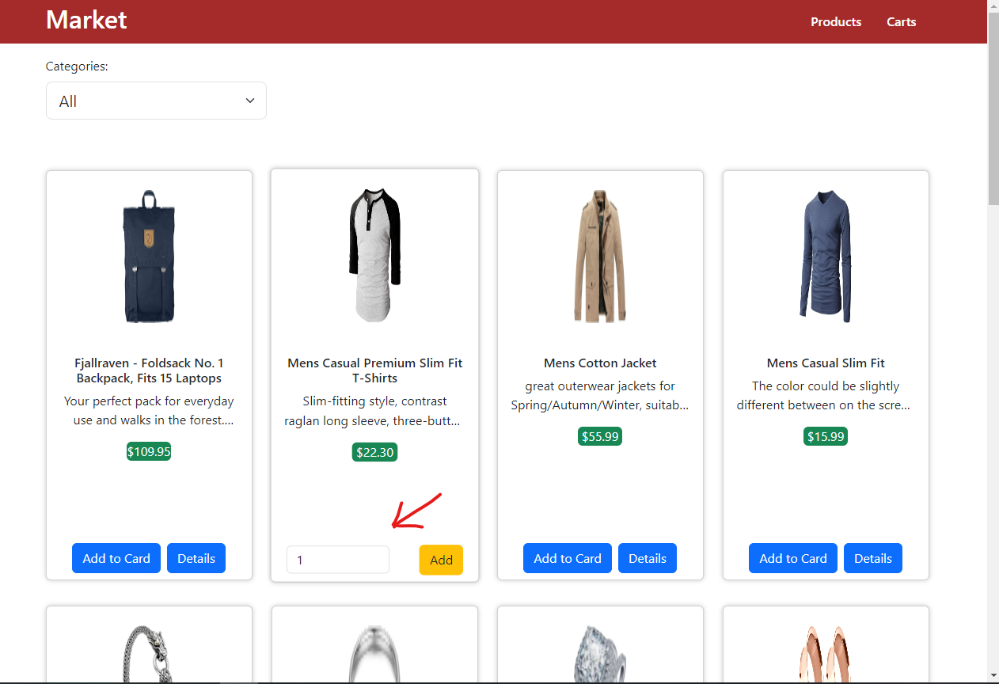

1. **Clear cart button**
2. **Increase numbers of product items**
3. **Decrease numbers of product items**
4. **Delete the product from the cart**
5. **Back to products page**

